CS18-A

PF LAB 6

Muhammad Ahmer Zaman

Q. No1: Write a C++ program Calculate the Bill until user Enter -999

If User enter -999 then Display the Total Bill

If Bill is greater than 5000 then give him/her 10% Discount else, No Discount

Code:

#include <iostream>

using namespace std;

int main()

{

int price=0,total=0,discount=0; //Declaring variables

cout<<"If you want to exit, enter -999 "<<endl;

while (price!=-999) //using sentinal while loop

{

cout<<"Enter Price of the item="; //displaying enter price

cin>>price; //Taking price from user until -999 is added

if (price!=-999) //checking whether price is not -999 to total

{

total=total+price; //Calculating total price

}

}

if (total>5000) //Checking whether total price is greater than 5000 or not

{

discount=total\*0.1; //Calculating discount

total=total-discount; //Subtracting discount from total

cout<<"With discount of 10%, your total bill is "<<total<<endl; //Displaying total with discount

}

else

{

cout<<"Your total bill is "<<total<<endl; //If total is less than 5000

}

return 0;

}

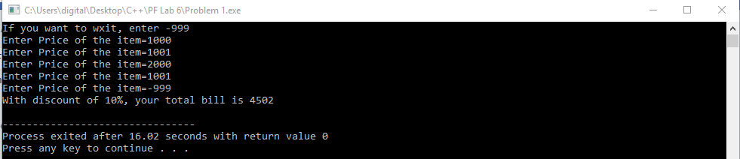

Q. No2: Write a C++ program that Calculate the Factorial of the Number Entered by the user.

If User Enter number less than 0 then Display the Error Massage.

Code:

#include <iostream>

using namespace std;

int main()

{

int factorial=1,number=0,numb2=0; //Declaring variables

cout<<"Enter any number you want to check factorial=";

cin>>number; //taking input from user

if (number>=0)

{

if (number==0)

{

cout<<"Factorial of "<<number<<"! is 1"<<endl;

}

else //If number entered is non zero

{

numb2=number; //Storing number in another variable

while (numb2>=1) //using while loop

{

factorial=factorial\*numb2; //calculating factorial

numb2=numb2-1; //Subtracting to get lesser number

}

cout<<"Factorial of "<<number<<"! is "<<factorial<<endl; //Showing factorial

}

}

else //If entered number is less than zero

{

cout<<"Error! You have entered invalid input."<<endl; //Displaying error message

}

return 0;

}

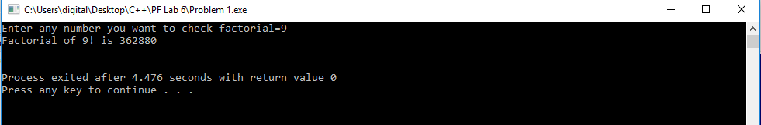

Q. No3: Design a C++ Program That Calculate the Sum of All INPUTS until INPUT is -999.

If the INPUT is -999 then Program Display the Sum of All the Numbers INPUT by User.

Code:

#include <iostream>

using namespace std;

int main()

{

int number=0,sum=0; //Declaring variables

cout<<"If you want to exit, enter -999 "<<endl;

while (number!=-999) //using sentinal while loop

{

cout<<"Enter number="; //displaying enter number

cin>>number; //Taking price from user until -999 is added

if (number!=-999) //checking whether price is not -999 to total

{

sum=sum+number; //Calculating total price

}

}

cout<<"The Sum of numbers is "<<sum<<endl; //Displaying Sum

return 0;

}

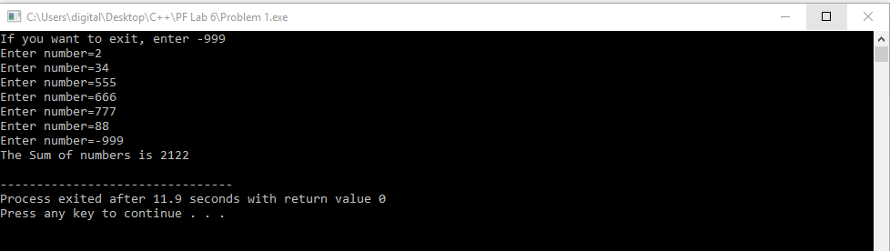

Q. No4: Print the Table of any Number. Length and Table Number Entered by The User

INPUT: Length, Table Number

Code:

#include <iostream>

using namespace std;

int main()

{

int number=0,length=0,count=1; //Declaring variables

cout<<"Enter Number you want to find table=";

cin>>number; //Taking table number from user

cout<<"Enter range to which you want to find table=";

cin>>length; //Taking length from user

while (count<=length) //Using while loop

{

cout<<number<<"\*"<<count<<"="<<number\*count<<endl;

count++;

}

return 0;

}

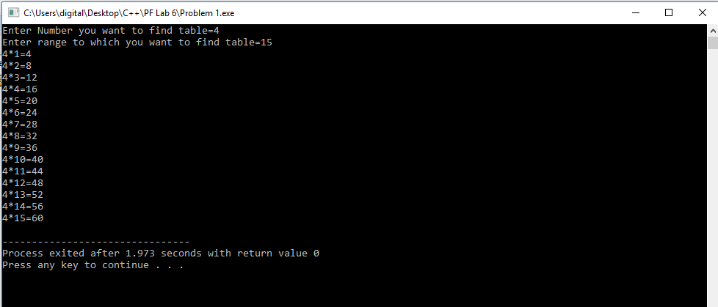

Q. No5: Write a C++ Program to print equilateral triangle or Pyramid star pattern series of n rows using for loop.

How to print Pyramid star pattern series in C++ Program. Logic to print pyramid star pattern series in

C++ Program Ming.

Input:

Input rows: 5

Output:

\*

\*\*\*

\*\*\*\*\*

\*\*\*\*\*\*\*

\*\*\*\*\*\*\*\*\*

Code:

#include <iostream>

using namespace std;

int main()

{

int blank,rows; //Declaring variables blank for controlling spaces and rows for rows

cout<<"Enter number of rows :";

cin>>rows; //Taking row number from user

for (int i=1,k=0 ; i <= rows ; ++i, k=0) //For loop for controlling rows

{

for (blank=1 ; blank <= rows-i; ++blank) //For loop for printing spaces from start

{

cout<<" ";

}

while (k != 2\*i-1) //While loop use for printing star and formula to print odd number of stars

{

cout<< "\* ";

++k;

}

cout<<endl;

}

return 0;

}

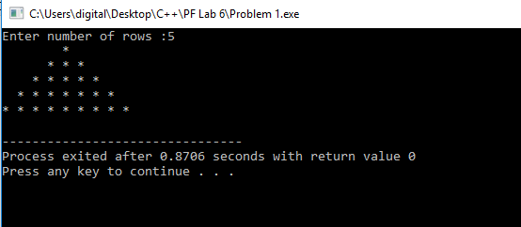

Q. No6: Write a C++ Program to print diamond star pattern series of n rows using for loop. How to print

diamond star pattern series in C++ Program. Logic to print diamond star pattern series in C++ Program

Ming.

Input:

Input rows: 5

Code:

#include<iostream>

using namespace std;

int main()

{

int row,i,j,k;

cout<<"Enter length :";

cin>>row;

for ( i = 1; i <= row; i++)

{

for (j = 1; j <= row - i; j++)

{

cout << " ";

}

while (k != (2 \* i - 1))

{

if (k == 0 or k == 2 \* i - 2)

cout << "\*";

else

cout << " ";

k++;

}

k = 0;

cout << endl;

}

row--;

for (i = row; i >= 1; i--)

{

for (j = 0; j <= row-i; j++)

{

cout << " ";

}

k = 0;

while (k != (2\*i-1))

{

if (k == 0 or k == 2\*i-2)

cout << "\*";

else

cout << " ";

k++;

}

cout << endl;

}

return 0;

}

